A000-Afr-D R Congo-Ituri-Mbuti-Barkcloth-1910

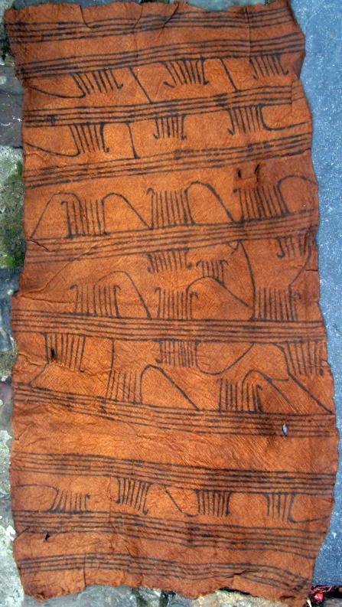

A fine example of a Mbuti Pygmy bark-cloth painting from the supa tree bark in the Ituri forest, ca. 1950 and painted with gardenia fruit (*embimbele*) for the black pigment. Antwerp, Ex Coll. Kim J. Nazzi, antiquaire, Rue de Rollebeek 36 - 1000 Bruxelles, Belgium. 71cm x 39cm.

The Mbuti can be divided into two groups based on their hunting with either nets or bows and arrows. Their bark cloth paintings highlight their particularly well-developed "abstract" art which is practiced almost exclusively by women. In fact, Mbuti women emphasize the connection between creative genius and madness: "The female artist works in a very complicated manner; the motifs tells us that she herself is very complex, perhaps even mad" (Meurant and Thompson 1995: 21).

The Mbuti are fiercely egalitarian in all aspects of life including bark-cloth manufacture. The husband collects barks from three different trees: light colored bark from the *lengbe* tree (as in the present specimen), brown bark from the *pongo pongo* tree and light red bark from the *supa* tree\. He then pounds the bark with an ivory hammer (*kolia*) until it is soft and pliable. He also collects and prepares the pigments. The wife applies her artistic designs using fingers, a twig or a piece of twine from the *kusa* plant to the bark-cloth (Hewlett and Cavalli-Sfroza 1991). Bark-cloth is used as a loincloth in forest camps by both men and women and so has a very utilitarian function on the surface. However, the loincloth also protects the user from the mysterious forest powers and so it may have a special symbolism vested in its ostensibly abstract designs. In fact, barkcloth designs and body painting have certain common graphic elements that may have apotropaic or protective significance (Turnbull 1965).

This present specimen dating to the 1910's is very rare because only 31 bark-cloth paintings from the Ituri forest had been collected prior to 1920 only ten bark-cloths had been collected by anthropologists A. Hutereau and H. Lang (Hutereau 1909; Lang, 1919). By 1934 only fifteen more had been collected by missionary anthropologist Paul Schebesta who worked among the Mbuti archers. Schebesta extolled Pygmy bark-cloth paintings as an art form in and of their own right, and he defended their primitive lifeway and its survival. The Mbuti made him one of them in recognition of his personal commitment to their survival and gave him the honorary title of *Baba wa Ba-mbuti* (Schebesta 1933, 1940; Anthropos 2012). By 1953 only three more bark-cloth paintings had been collected by Patrick Putnam, an American anthropologist who had come to the Ituri forest in 1928 (Putnam 1948; Meurant and Thompson 1995:20). This is the period of the present specimen. When Colin Turnbull visited Putnam in 1951 he was so impressed by the Mbuti and Putnam's labors (building a dispensary and a leper hospital) that Turnbull devoted the rest of his career to studying the Mbuti net hunters, and he collected another three specimens (Meurant and Thompson 1995:20).

The present specimen is unusual for the designs in their repetative sequence. Beginning at the "top" register (1A) are motifs building on the dot and the dash symmetrically organized around an axis like stars. These are called "constellations" by ethnologists (Meurant and Thompson 1995: 128-129, fig. I, 18). At the top right (1B) are small groups of straight or curved lines, or lines creating chevrons (Meurant and Thompson 1995: 128-129, fig. I, 16). In the next "register" (2) are parallel lines with added motifs suggesting linear progression (Meurant and Thompson 1995: 132-133, fig. III 5). In the third register there is a larger field with parallel lines, dots expanded into curvilinear, star-like designs with added motifs. Finally the fourth register represents an integration of dashes arranged along three axes: vertical, horizontal and diagonal (Meurant and Thompson 1995: 132-133, fig. III,6). These have the force of a linear progression (Meurant and Thompson 1995: 136-137, fig. V, 11, 13. All of these design elements and constellations of clustered motifs can be without explicit symbolism, but implicitly the artists can often provide detailed symbolic explanations. These are clandestine symbolisms like the depths of the forest in which they reside, mysterious yet vibrant and full of energy (Hewlett and Cavalli-Sforza. 1991). For the present specimen we do not have this clandestine symbolic information. Importantly, a similar clandestine symbolism may be present in rock art, whether petroglyphs or pictographs. Therefore, our description of the designs on this Mbuti barkcloth is only descriptive and without any profound meaning that may have been intended by the artist.

References:

Anthropos. 2012. http://www.anthropos.eu/anthropos/heritage/schebesta.php. Accessed 25 Sept 2012.

Hewlett, Barry S. and L. Cavalli-Sforza. 1991. Barkcloth Designs of Mbuti women. *Human Mosaic: A Journal of the Social Sciences*, 25(1&2):1-9.

Hutereau, A. 1909. Notes sur la vie familiale et juridique de quelques populations du Congo Belge. Ann. Mus. du Congo Beige, Ethnog. et Anthrop., ser. 3, Doc. Ethnog., vol. 1, fasc. 1.

Lang, H. 1919. Nomad dwarfs and civilization. Nat. Hist., Amer. Mus. Nat. Hist., vol. 19, no. 6, pp. 696-713.

Meurant, Georges and Robert Farris Thompson. 1995. *Mbuti design: paintings by Pygmy women of the Ituri forest*. New York: Thames and Hudson.

Putnam, Patrick. 1948. The Pygmies of the Ituri Forest. *In* Coon, C. S. (ed.), *Reader in general anthropology*. New York, pp. 322-342.

Turnbull, Colin. 1965. *The Mbuti Pygmies: an ethnographic survey.* New York: American Museum of Natural History.

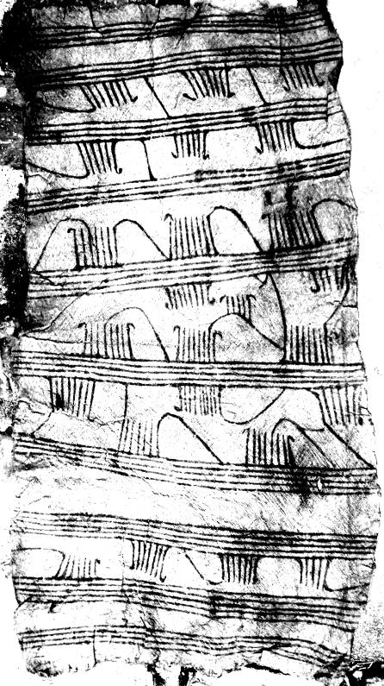 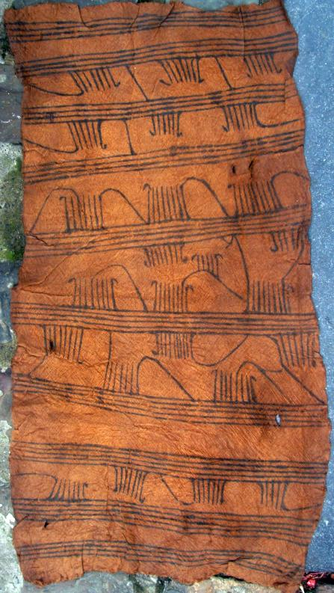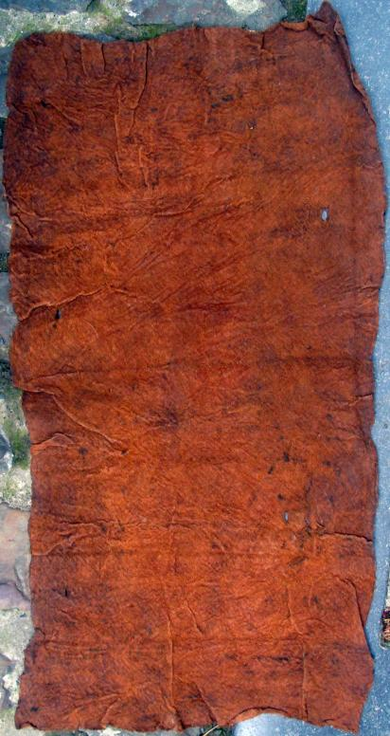

|  |  |  |
| --- | --- | --- |
| Seller: | [**Member id** x-entrix](http://myworld.ebay.com/x-entrix) ( [**Feedback Score Of** 1486](http://feedback.ebay.com/ws/eBayISAPI.dll?ViewFeedback&userid=x-entrix)) | [Contact seller](http://contact.ebay.com/ws/eBayISAPI.dll?ShowCoreAskSellerQuestion&frm=3998&iid=200821794341&redirect=0&requested=x-entrix) |

|  |  |  |  |  |
| --- | --- | --- | --- | --- |
| Paid on Sep-25-12 via PayPal | | | | |
|  |  |  |  |  |

|  |  |  |  |  |  |  |  |  |
| --- | --- | --- | --- | --- | --- | --- | --- | --- |
|  | [**Item Title:**A very fine PYGMY BARK-CLOTH. R.D. CONGO. Early 20thC. Old private coll. **- opens in a new window or tab**](http://cgi.ebay.com/ws/eBayISAPI.dll?ViewItem&item=200821794341)  **Item Id:**200821794341 - Price: US $175.00  Quantity:1  Having a problem with this purchase? [We can help](javascript:;) | |  | | --- | |  | | |  |  | | --- | --- | | [Leave feedback](http://feedback.ebay.com/ws/eBayISAPI.dll?LeaveFeedbackShow&useridfrom=802-867&useridto=x-entrix&item=200821794341&transactid=792668883010) |  | | | Economy Shipping: **US $25.00**  Estimated delivery on or before Mon. Oct. 01 | US $175.00 |